# Selwyn District Risk Assessment and Communication (Non-Technical Summary)

Selwyn District is the home to several schools that play a pivotal role in the education and wellbeing of the Tamariki. The Selwyn River / Waikirikiri runs Selwyn and poses a flood risk to the schools in the area. This analysis aims to evaluate the flood risk for each of the schools in accordance with the methodology specified below by integrating the flood hazard data from Task 1 and the school location and demographic data from Task 2. By assessing the potential consequences and uncertainties associated with flood hazards, the study provides insights to guide emergency planning and aid long-term decision-making.

## 1. Methodology

### 1.1 Flood Hazard Analysis

My primary method of analysis is the overlaying of school locations on the flood vulnerability classification colourmap. This provides quantitative and visual data to assess site-specific hazards. The flood vulnerability colourmap highlights the areas of the Selwyn District that may be negatively impacted in the event of a flood. It displays six different classifications of flood vulnerability, as described in Smith et al (2014). The school data contains basic information about the school, including its location, and statistics of the SA1 the school is in. This data is sourced from the Education Counts online directory, and the 2023 Census.

I generated an image of Selwyn with flood vulnerability classifications coloured in accordance with Figure 5-5 from Smith et al (2014). Specifically, blue areas correspond to low-risk areas (H1 & H2), and the red areas correspond to high-risk areas (H6). For the purposes of analyzing the risk to schools, a classification of H3 or above is considered a hazard to the school. On the image, this means that any schools located in green, yellow, or red area are at risk.

### 1.2 Risk Assessment

For this report, I am using the definition of risk as ‘consequences and associated uncertainty’. The consequences of a flood through or near a school can be severe for both people (students, teachers, parents) and the surrounding area itself. Depending on the depth and velocity of a flood, a civilian can experience injuries, trauma, or even death. Furthermore, consequences for school children are elevated compared to the general population. Additionally, a flood can also damage or destroy school buildings, roads leading to and from a school, and vital infrastructure.

For a quantitative understanding of the risk, I am using the flood hazard vulnerability classification system outlined in Table 5-1 in Smith et al (2014). The system sets forth six classifications (H1 to H6) that represent increasing levels of vulnerability. For this analysis, any school in area with an H3 classification or higher is considered at risk. This is because areas of H3 and above are not safe for children.

### 1.3 Uncertainties in the Risk Assessment

It is important to consider are the uncertainties present in the risk analysis. Many uncertainties stem from the flood modelling, including simplifications in the flow dynamics and potential errors in digital elevation models. Additionally, the school data may include errors such as imprecise location or old roll numbers. Not included in the school dataset are descriptions of the building conditions, which play a significant role in assessing flood risk. Furthermore, this analysis does not include any information regarding levels of disaster preparation for each school community. When assessing the risk for these schools, it is important to consider how these uncertainties and missing context impact my recommendations.

### 1.4 Prioritization Methodology

The primary factor that contributes to the prioritization and ranking of risk each school faces is the flood vulnerability classification at the school’s location. Additionally, there are lesser factors to consider. These include the distance to more vulnerable areas, the school’s roll, and the population of children in the area. For schools that share the same vulnerability classification, these factors determine which schools are at more risk and therefore require additional planning or safety. Due to the inherent uncertainty of the underlying flood modelling, the distance to more vulnerable areas is particularly crucial. The school roll is important because a larger student population makes potential evacuation efforts more challenging.

Whilst not included in the data I’ve collected; the level of disaster preparation and the physical condition of the school buildings must also contribute to the flood risk ranking. For a more complete analysis, it is most important for these uncertain factors to be resolved for the schools that have a higher risk, based on the factors outlined in the previous paragraph.

## 2. Results and Analysis

### 2.1 Quantitative Results

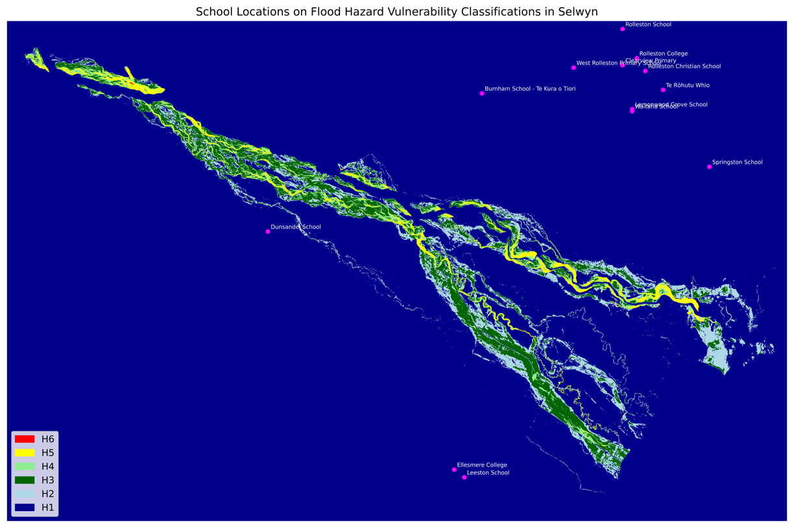Following the methodology outlined in Section 1.1, I have generated an image of Selwyn coloured according to the flood hazard vulnerability classifications. This image (Figure 1-1) shows that all schools in the Selwyn District are in areas classified as H1, meaning they are generally safe for vehicles, people, and buildings. As such, the other factors outlined in Section 1.3 must be considered. All but three of the schools are quite a distance away from more vulnerable areas. These three schools, all located south of the more vulnerable areas, are at a greater risk than the others. Of the three, Dunsandel School is the closest to an H3 or above area and has a roll of 136. The other two, Ellesmere College and Leeston School, are further away, but have higher rolls with 503 and 313 students, respectively.

Figure 1-1

### 2.2 Further Analysis Required

As mentioned in the prioritization methodology, a more complete analysis could be achieved by conducting research into the disaster preparations and physical condition of school buildings for these three schools. With that information, the three could be differentiated and preventative measures could be assigned to the most vulnerable school first.

## 3. Summary

By analyzing the flood vulnerability of the Selwyn District, combined with school locations and demographics, we can evaluate the flood risk to these schools. Risk was assessed as combination of the potential consequences and the uncertainties surrounding their likelihood and severity. Assuming the flood modelling data is accurate to a reasonable degree, the visualization model shows that all schools in the Selwyn District are located within an H1 flood vulnerability area. This classifies them as generally safe for vehicles, people, and buildings.

Dunsandel School has the closest proximity to more vulnerable areas, so further analysis is necessary to resolve uncertainties that contribute to the risk. An in-depth analysis of the condition of the school’s buildings, the quantity and quality of roads leading to the school, and the general disaster readiness of the surrounding community would allow for a more accurate risk assessment, and a better targeted preventative measures.

Whilst this analysis does not indicate the need for urgent action, climate change is increasing the flood risk across the country. Rising sea levels result in that floods that are deeper and flow faster. A hotter climate leads to drier soil which decreases moisture absorption, increasing the velocity of floods. This analysis provides a foundation for informed decision-making on the safety of schools, students, and staff against future flood events. As such, it is important to regularly perform this analysis as the climate shifts so that Selwyn District schools are prepared.